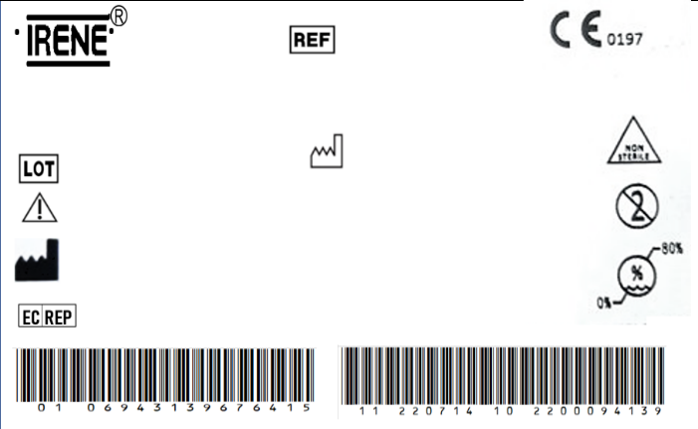

4.0mm Locking Screw

0707.202.002XN

2200048571

44680

REGISTRO SANITARIO

5753-DME-1018

IMPORTADO Y DISTRIBUIDO POR ORTOMAX- PINEDA CORAL JAIRO DARIO

The implante should be sterilized before surgery.

TianJin ZhengTian Medical Instrument Co., ltd.

No. 318, Jingyi Road

Airport Economic Zone 300308 TianJin P.R. China

Bricon GmbH

EisenBahnstrasse 100, 78573 Wurmlingen, Germany



4.0mm Locking Screw

0707.202.002XN

2200048571

44680

REGISTRO SANITARIO

5753-DME-1018

IMPORTADO Y DISTRIBUIDO POR ORTOMAX- PINEDA CORAL JAIRO DARIO

The implante should be sterilized before surgery.

TianJin ZhengTian Medical Instrument Co., ltd.

No. 318, Jingyi Road

Airport Economic Zone 300308 TianJin P.R. China

Bricon GmbH

EisenBahnstrasse 100, 78573 Wurmlingen, Germany